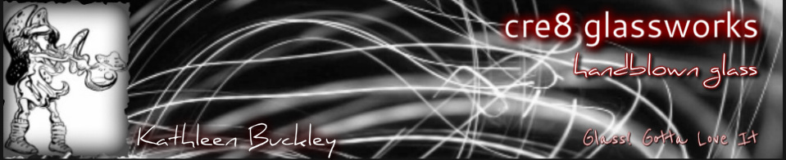
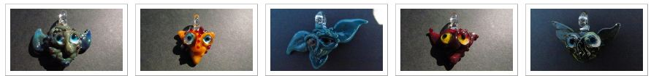
Kathleen Buckley  Has been working freehand glass since 1999, in the tradition of glassblowing known as lampworking or flame working, exclusively using borosilicate or 'hard' glass. Lampworking borosilicate glass involves using a torch flame fuelled by an oxygen/propane gas mix to heat the glass freehand to the melting point, where it can be shaped, designed, and blown in a wide variety of specific techniques. Once completed, glass pieces are annealed in a kiln. At the molten level, glass is flexible like taffy, and the colour palette allows for some wonderful hues and striations of shade. Borosilicate glass (hard glass; the same type of glass as used in Pyrex cookware) is especially good to work with as its increased hardness makes it highly resistant to breakage. It has also holds a very refined clarity. | The momentum involved in the process is exciting and challenging, while the classic beauty of glass is enchanting. Even after ten years, the allure constantly pulls me to the studio. Whether I'm making small drops or large custom sculptural work, the passion is there. They are each made individually, and consistent lines and series have subtle differences which highlight the singularity of time and focused attention to make each piece.  My work is available at several stores...if there are none available in your area, please feel free to contact me personally via email concerning sales and custom orders.  Kathleen Buckley  250 885 8075  cre8glassworks@gmail.com  cre8glassworks.weebly.com

